**Year 9 Chemical Sciences - Test/ Quiz 2**

Name: ___________________ Class: __________ Mark: /40

**Multiple Choice :** Write the letter of the answer that you think is most correct

1. Use this information to answer this question.

|  |
| --- |
| Atomic No. 9  F  Mass No. 19 |

From the information box above we can see that one of the following statements is true. Which one is it?

1. Francium has more electrons than protons.
2. Iron has more protons than neutrons.
3. Flourine has more neutrons than protons.
4. Francium has 10 neutrons.

Answer: ____

1. In the equation below what are the reactants?

H2O + CO2(aq)  H2CO3(aq)

1. Hydrogen Carbonate
2. Oxygen and carbon dioxide.
3. Carbon dioxide and water.
4. There are no reactants in this equation.

Answer: ____

1. How many valence electrons does the atom below have?

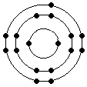

1. 17.
2. 2.
3. 7.
4. 4

Answer: ____

1. Argon is a noble (inert) gas. Which of the following is correct?
2. Argon is found on the far right of periodic table & has 1 valence electron.
3. Argon is found on the far left of periodic table & has 1 valence electron.
4. Argon is found in the transition metals & has 4 valence electrons.
5. Argon is found on the far right of periodic table & has all of its shells (orbits) full.

Answer: ____

1. Which of the following is correct?
2. Silver will lose electrons when forming ions.
3. Oxygen will lose electrons when forming ions.
4. Silver is a precious metal so it will never lose or gain electrons.
5. Metals do not become charged.

Answer: ____

1. Acids and bases are sometimes called chemical opposites. What is one thing that they both have in common?
2. They taste sour.
3. They are corrosive.
4. They produce helium when added to metals.
5. They turn blue litmus paper red.

Answer: ____

1. Some atoms can lose electrons. Some atoms can gain electrons. When atoms lose or gain electrons they form:
2. Ions.
3. Acids.
4. Bases.
5. Salts.

Answer: ____

1. Elements in the same column of the periodic table will all have which of the following in common?
2. The same atomic number.
3. The same Mass.
4. The same number of protons.
5. The same number of valence electrons.

Answer: ____

1. Which of the following will turn blue litmus paper red?
2. Vinegar.
3. Sodium hydroxide.
4. Distilled water.
5. Glucose solution.

Answer: ____

1. The electrons in an atom are stored:
2. In shells.
3. In the nucleus.
4. In nuclear orbits.
5. In the cell membrane.

Answer: ____

**Written section.** Answer all of these questions in the spaces provided.

1a. Use the information in the box to complete the table below.

|  |
| --- |
| **11**  **Na**  **23** |

|  |  |  |  |  |  |
| --- | --- | --- | --- | --- | --- |
| Name of element | Metal or non-metal? | Number of electrons | Number of protons | Number of neutrons | Mass number |
|  |  |  |  |  |  |

(6 marks)

1.b. Into the space below draw the electron configuration diagram for the element shown above.

(3 marks)

1.c. How many valence electrons does an atom of the element shown above have?

_____________________

(1 mark)

1.d. What is likely to happen to this element in order for it to have a complete outer orbit? ____________________________________________________

____________________________________________________________________________________________________________________________________________________________________________________________________________________________________________ (2 marks)

2. Complete the table to compare the characteristics of acids and bases.

|  |  |  |
| --- | --- | --- |
| **Characteristic** | **Acid** | **Base** |
| Taste |  |  |
| What colour does it turn Universal Indicator? |  |  |
| Is it corrosive?  Yes or no? |  |  |

(3 marks)

1. List 3 acids that are safe to use in food?

* ___________________________________________
* ___________________________________________
* ___________________________________________ (3 marks)

1. An experiment was conducted to see if the shampoo recommended for different Hair Types had different pH levels.

|  |  |
| --- | --- |
| **Shampoo Type** | **pH** |
| “Special Salon” - Coloured Hair | 4.2 |
| “Special Salon” - Dry Hair | 4.3 |
| “Special Salon” - Oily Hair | 2.2 |

Three “Special Salon” shampoo samples were tested once with 3 drops of Universal Indicator and their pH recorded.

4a. What is the independent variable?__________________________________

______________________________________________________ ( 1 mark)

4b. What is the dependent variable?___________________________________

_______________________________________________________ ( 1 mark)

4c. What can you conclude from the results about shampoo hair types? ________

________________________________________________________________________________________________________________________________________________________________________________________________________________________________________________( 2 marks)

4d. Suggest two improvements to the experiment to make it a fair test? ________

____________________________________________________________________________________________________________________________________________________________________________________________________________________________________________ (2 marks)

1. Use the two tables below to answer the question.

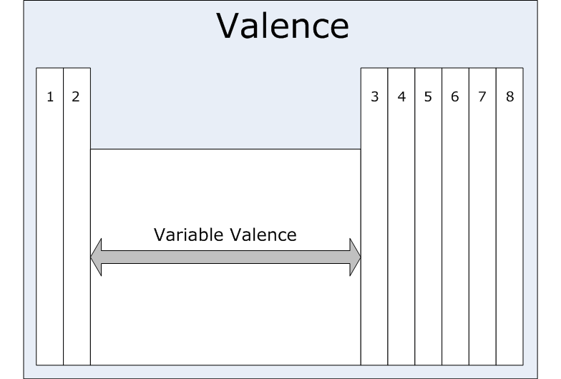

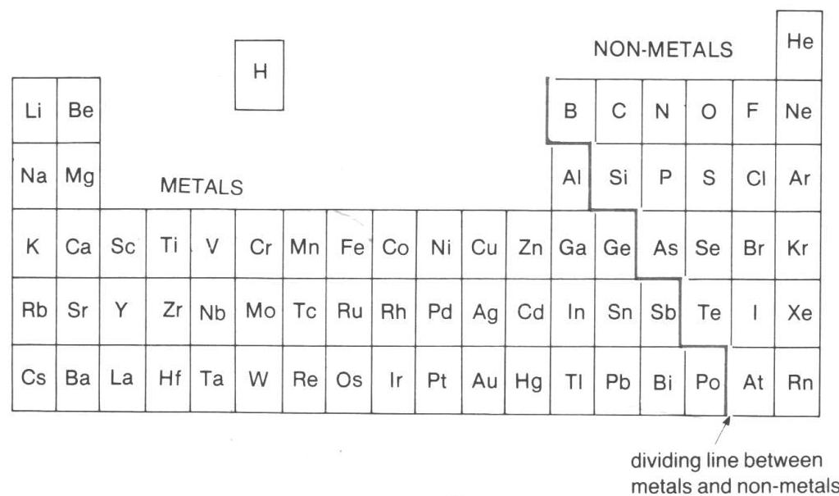

1. Complete the table. For each element include: the chemical symbol, the number of valence electrons and whether it is a metal or non-metal.

|  |  |  |  |
| --- | --- | --- | --- |
| Element | Symbol | Number of valence electrons | Metal or  non-metal |
| Calcium |  |  |  |
| Oxygen |  |  |  |
| Chlorine |  |  |  |
| Magnesium |  |  |  |
| Neon |  |  |  |

(6 marks)

END of TEST – Check through ALL your answers.